The school will provide a student planner at the beginning of the year
(students are expected to use the ASD MS Planner all year)

Core Classes (All Students):
- Five large (100+ pages) Spiral notebooks (one for Science, Spanish)  - Pack of Graph Paper (not log graph paper but 0.5cm or 0.25cm grid for Math 8 and Algebra I)  - Pencils with erasers and pens (Students will be expected to have these throughout the year.)  - Highlighters (4 pack) | - Small pencil sharpener (NOT electric)  - Combination padlock for the locker (NO locks with keys)  - Reusable Water Bottle with the name in permanent marker  - Pencil Case  - Pack of Sticky Notes

Computer Supplies (All Students):
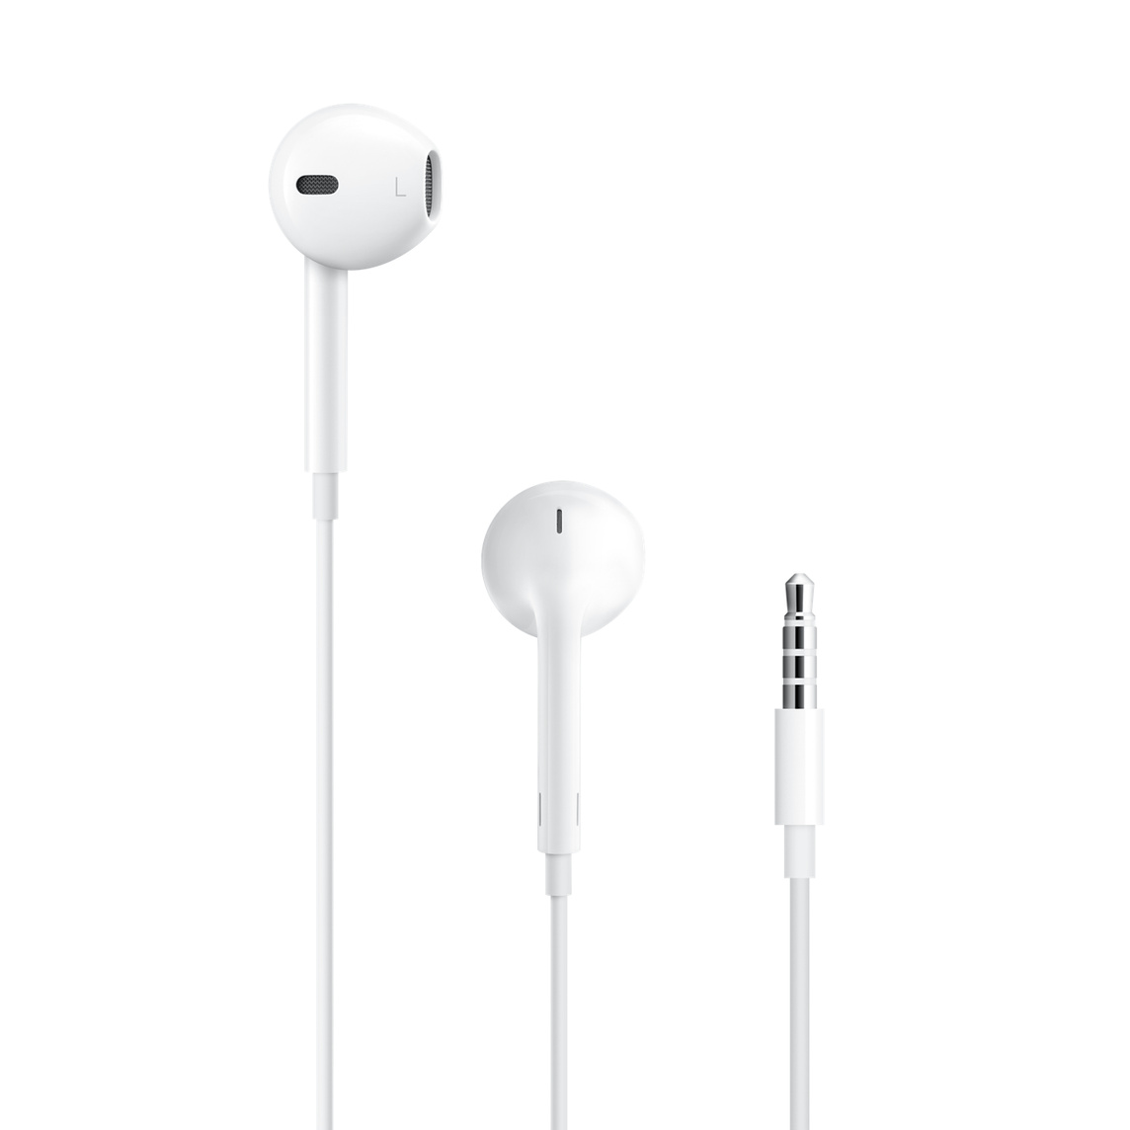 | Earphones with microphone  Please ensure that the earphones are specifically designed so that the microphone works with Apple products.
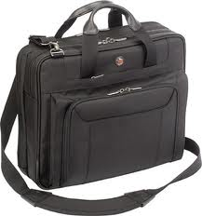 | Laptop Shoulder Bag  The computer bag must:  - Be padded  - Have a shoulder strap (note that this is not a laptop “sleeve”)  - Have an external pocket for the charger  - Be sized to fit at least a 13-inch MacBook Air laptop, but not be much larger than required.  - Must NOT be a backpack that carries books or other items. The Computer Bag should be for the computer, charger, and earpod only.

Math 8 & Algebra I
- Scientific Calculator
  - We recommend the TI - 30XS Multiview OR the TI - 34 Multiview as they are similar to the graphing calculators required in High School
- Graph Paper

WORLD LANGUAGES

Spanish D students only
- Glue stick or scotch tape
- Headphones
- Pens & pencils
- Notebook provided

French students only
- Pens (blue, red, green)  - Elastic folder (one folder only) =>  - One notebook (Stapled notebook) 21x29,7 cm 24sh. Seyès - Mimesys, in polypropylene - Clairefontaine brand or Oxford brand => | 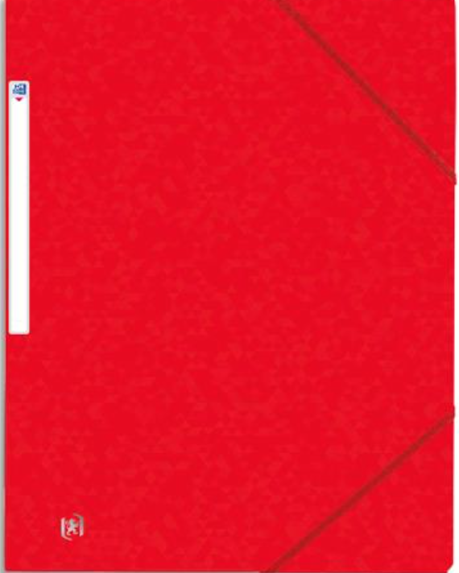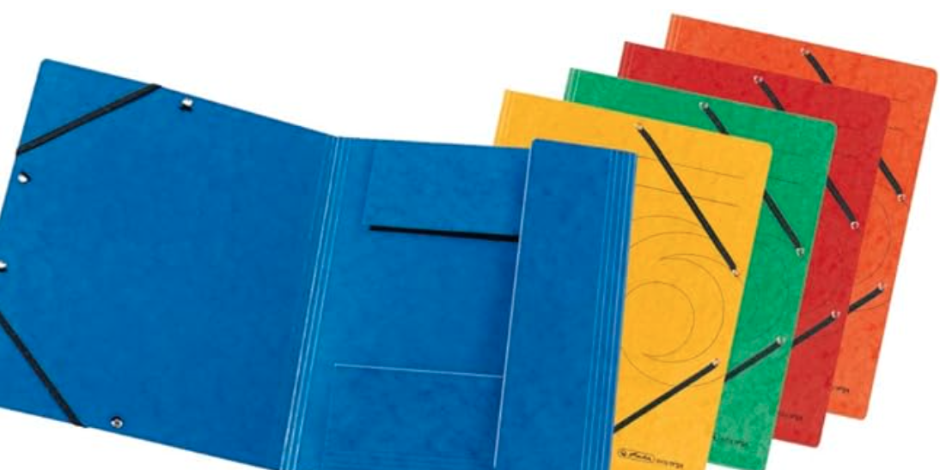  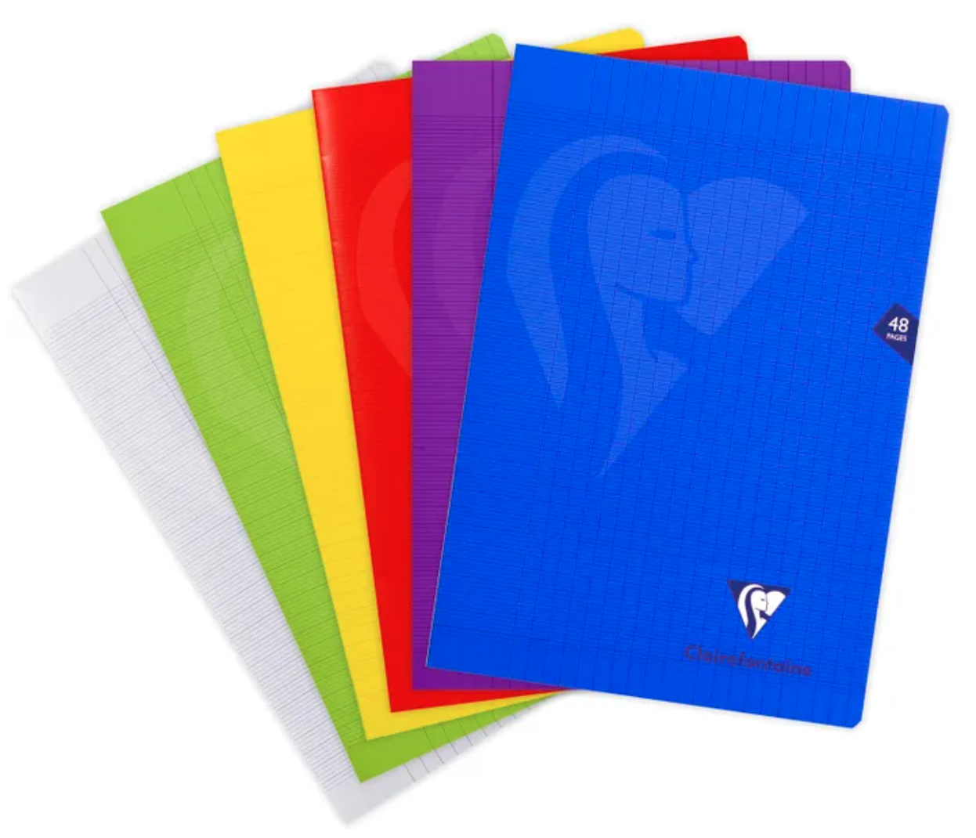

Arabic as a Foreign Language (AFL) students only
- Folder with Multiple Pocket (one only)
- Post-it tabs (one pack)

Modern Standard Arabic (MSA) students only)
- Folder with Multiple Pockets (one only)
- Headphones
- Pens & pencils
- Highlighters

Art Supplies (Art Students only):
All Required by the first day of class:  - Pencil case  - 1 fine tip permanent black marker  - 1 extra fine tip permanent black marker  - large eraser  - 2 pencils  - hand-held pencil sharpener  - 1 large glue stick  - Spiral Bound Sketchbook  ** Art supplies stores: Jarir Bookstore, Fire station Art shop, Color Note, Carrefour, WH Smith | 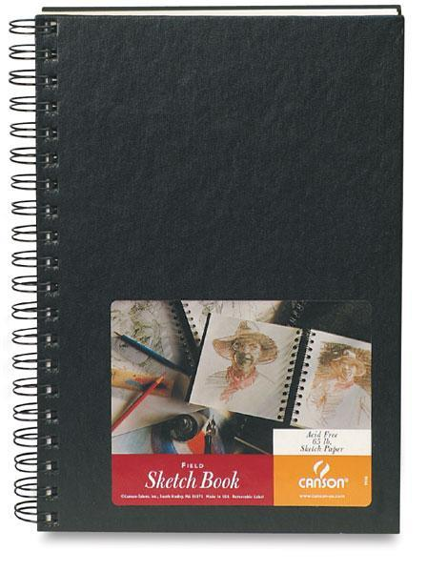  The spiral-bound sketchbook should look similar to this and have unlined white pages. It should measure around 9 x 12” (A4). When purchasing a sketchbook, please make sure that it is for drawing and NOT for watercolors or some other medium. It should say “sketch” somewhere on it.

PE Supplies (All Students):
- Deodorant for PE class
- Water bottle
- MS requires students to wear a school approved PE uniform. Uniforms can be purchased from Noble House
They have a store and an online ordering system. More information can be found in Sahifa and on the PE Teneen page
- Swimming Unit: Swim cap required and goggles strongly recommended

Drama (Drama Students only)
- A blank journal - this can be a notepad of any size and design
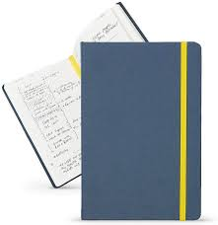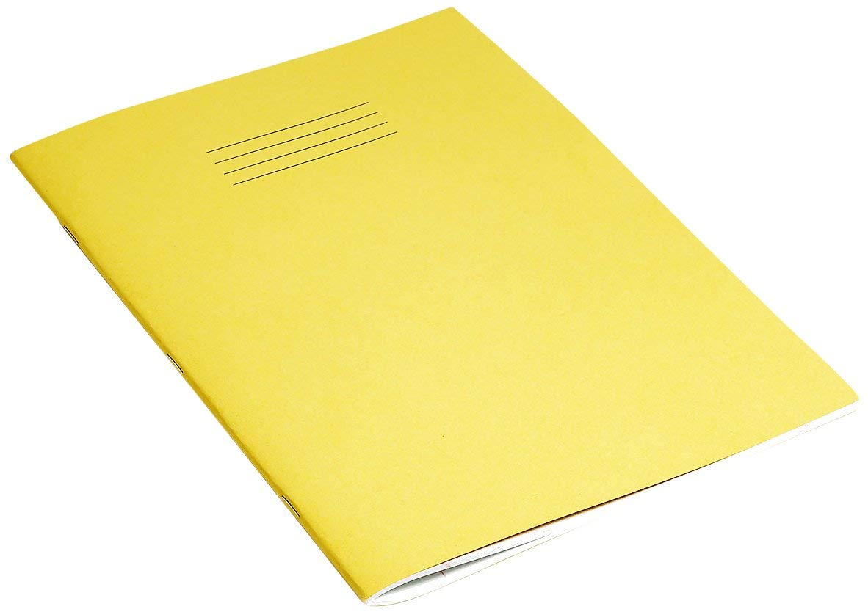

Music Supplies (Music Students only)
Please note: There is a 600 QR non-refundable fee for the rental of school-owned instruments. This is non-refundable. However, if students have their own instruments, or if students take choral music, there is no fee. All band students will be provided with a band method book at no cost.

The ASD Booster Club Store Will be selling:
- Combination Locks
- Swim caps
- Stainless steel water bottles

Special Days at ASD (for International Week and Week Without Walls)
You may want to consider bringing some special items from home for international week/Week without Walls including the following:
- National Dress
- Favorite sports jersey
- National colors t-shirt
- Hiking/water shoes (Keen, Teva, Chacos, etc.)
- Lightweight raincoat/poncho
- Quick-dry clothing
- Bug spray (with DEET)
- Swimming shorts for boys and girls
- Tankinis for girls
- Lightweight/compact sleeping bag

ASD Dress Code

Our dress code is meant to provide guidance for students and parents as to suitable attire for our school’s learning environment. While ASD does not have a school uniform (with the exception of clothes for P.E.), all students are expected to dress in a manner that both reflects our school values and contributes towards an academic atmosphere.

- Students’ clothes should cover their body from (and including) their shoulders down to three inches above the knee, as well as the waist. Wearing clothes that have holes or are see-through in this area is not acceptable. Also, underwear should not be visible.
- Jewelry, glasses, and t-shirt decorations and logos should be culturally sensitive and not offensive or inappropriate. Hats and sunglasses may only be worn outdoors.
- Distracting personal devices, such as cell phones and smartwatches, should not be worn or used during the school day. If they are brought to school, they should be turned off and put away in a student's locker.

If a student’s dress is not in line with these guidelines, they will be asked to change. If the student does not have alternate clothing, parents will be contacted. Please note that our dress code remains in effect during school-sponsored activities, including school socials and field trips.
Note: Dress Code During P.E.
Students are required to wear a P.E. uniform for their physical education classes. Middle school students that still have last year’s P.E. uniform (and it still fits) are welcome to wear it during this year’s classes.

