The school will provide a student planner at the beginning of the year
(students are expected to use the ASD MS Planner all year)

General 7th Grade Materials:
- Two spiral (or sewn) notebooks with graph paper (A4 or 8 ½ x 11) (both for Math)  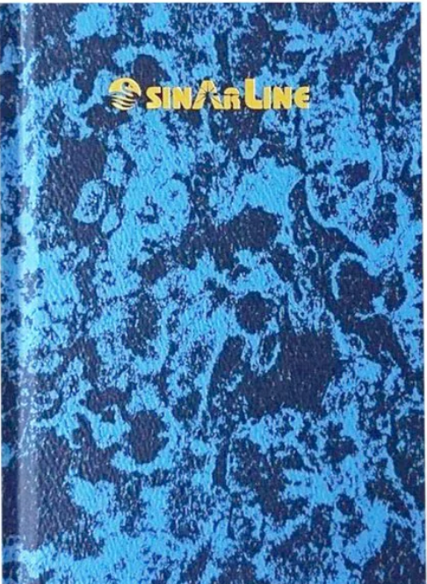  - One lined notebook for Social Studies (A4 or 8 ½ x 11)  - Register Book Hard-Cover A4 Size Sinarline (can easily be found locally in Doha)  - Scientific Calculator (We recommend the TI - 30XS Multiview OR the TI - 34 Multiview as they are similar to the graphing calculators required in High School)  - Ruler  - One pencil case  - Colored pencils  - Erasable or Ballpoint Pens (blue and black ink)  - 4 Black Expo or Staedtler dry erase markers (math) | - Reusable Water Bottle with the name in permanent marker - no glass ones  - Highlighters  - 2 boxes of 12 Pencils  - Erasers (white block ones are the best)  - Post-It Notes (7cm x 7cm) 2-packs (any color)  - Compass & Protractor (Geometry kit)  - Folder with Multiple Pockets  - Glue Stick  - 1 Combination Lock (optional)

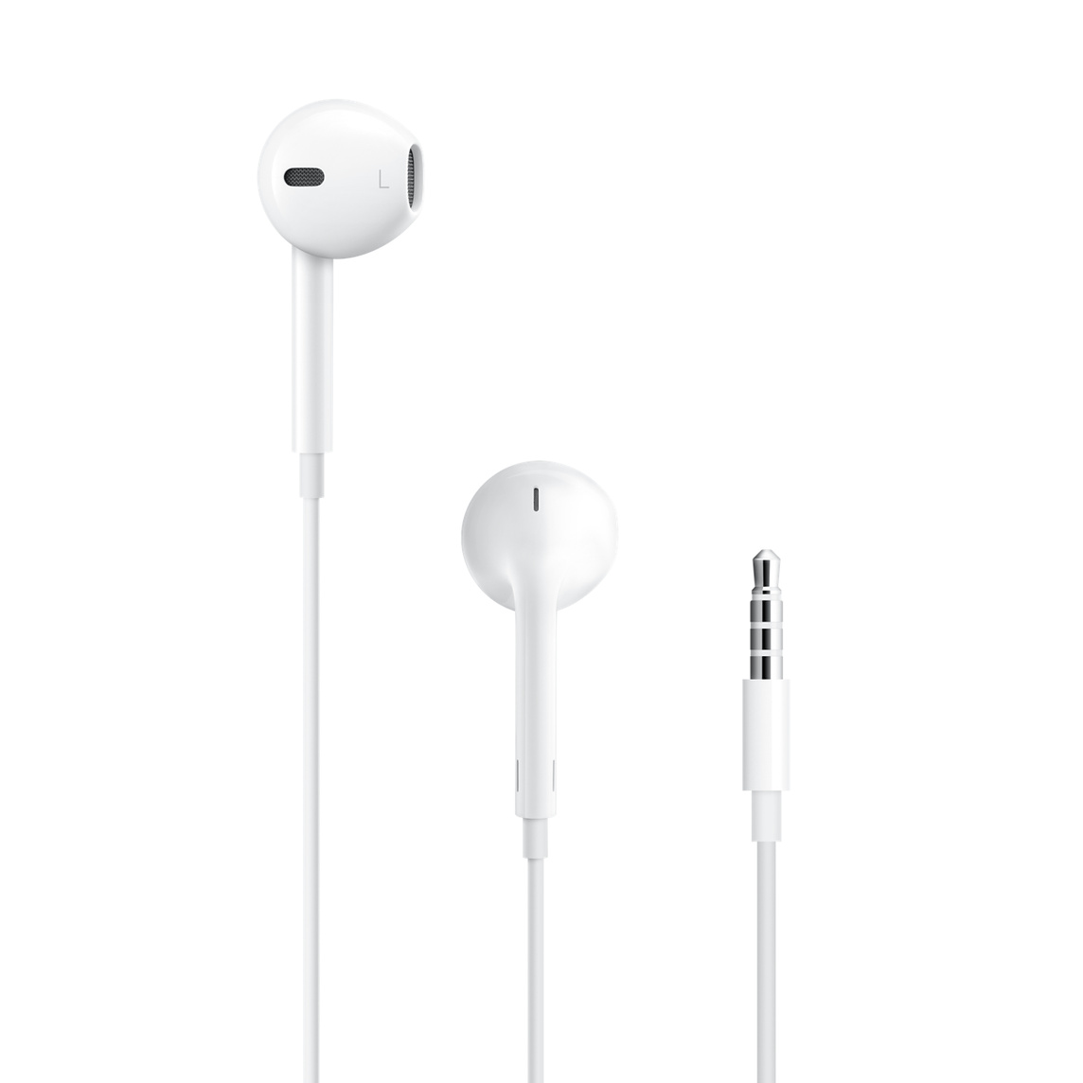 | Earphones with microphone (Dedicated for school - cheaper rather than more expensive!)  Please ensure that the earphones are designed so that the microphone works with Apple products.
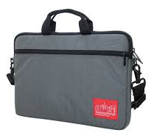 | Laptop Shoulder Bag  The computer bag must:  - Be padded  - Have a shoulder strap (note that this is not a laptop “sleeve”)  - Have an external pocket for the charger  - Be sized to fit at least a 13-inch MacBook Air laptop, but not be much larger than required.  - Must NOT be a backpack that carries books or other items. The Computer Bag should be for the computer, charger, and earpod only.

Art Supplies (Art Students only):
All Required by the first day of class:  - Pencil case  - 1 fine tip permanent black marker  - 1 extra fine tip permanent black marker  - large eraser  - 2 pencils  - hand-held pencil sharpener  - 1 large glue stick  - Spiral Bound Sketchbook  ** Art supplies stores: Jarir Bookstore, Fire station Art shop, Color Note, Carrefour, WH Smith | 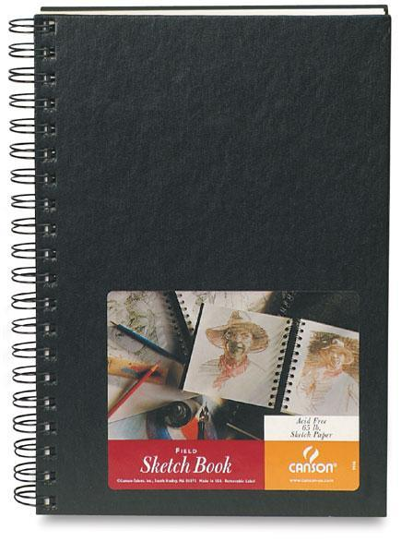  The spiral-bound sketchbook should look similar to this and have unlined white pages. It should measure around 9 x 12” (A4). When purchasing a sketchbook, please make sure that it is for drawing and NOT for watercolors or some other medium. It should say “sketch” somewhere on it.

Music (Music Students only)
- Please note: There is a 500QR non-refundable fee for the rental of school-owned instruments. This is non-refundable. However, if students have their own instruments, or if students take choral music, there is no fee. All band students will be provided with a band method book at no cost.

Drama (Drama Students only)
- A blank journal - this can be a notepad of any size and design
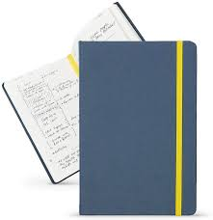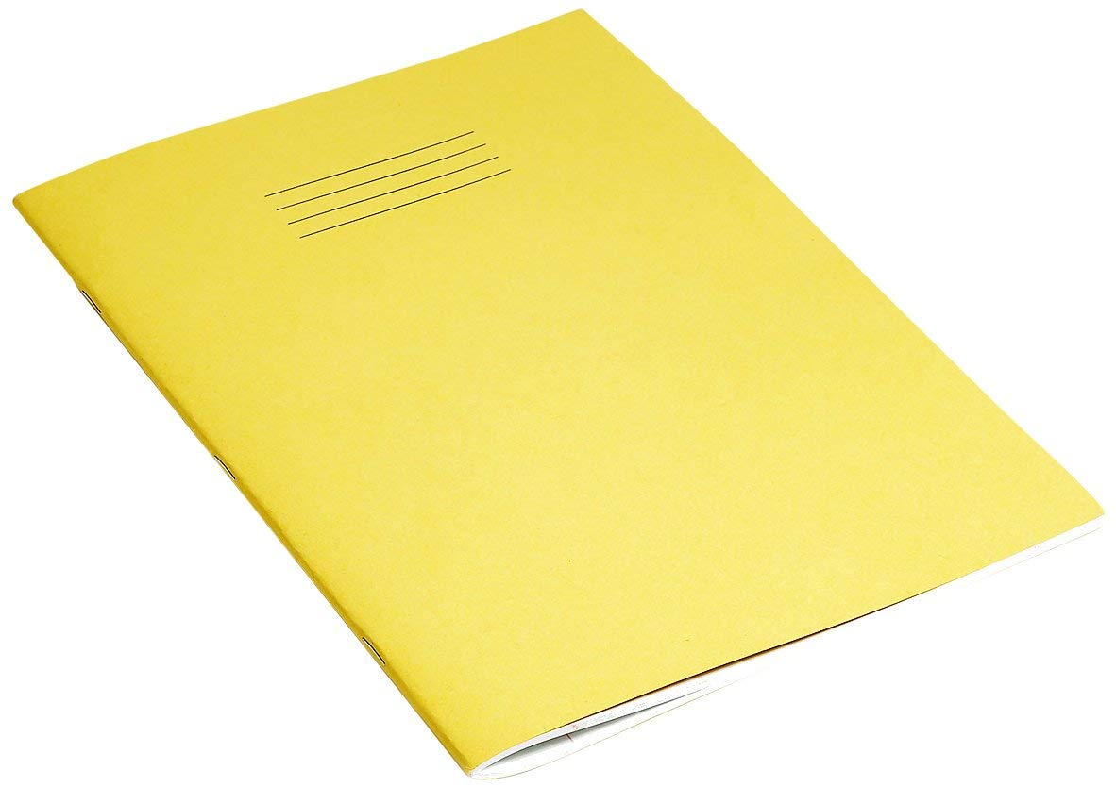

PE Supplies (All Students):
- Deodorant for PE class
- Water bottle
- MS requires students to wear a school approved PE shirt. Shirts can be purchased from Noble House
(School Code - ASD3005). They have a store and an online ordering system. More information can be found in Sahifa and on the PE Teneen page.
- Swimming Unit: Swim cap required and goggles are optional

WORLD LANGUAGES

Spanish D students only
- Glue stick or scotch tape
- Headphones
- Pens & pencils
- Notebook provided

French students only
- Pens (blue, red, green)  - Elastic folder (one folder only) =>  - One notebook (Stapled notebook) 21x29,7 cm 24sh. Seyès - Mimesys, in polypropylene - Clairefontaine brand or Oxford brand => | 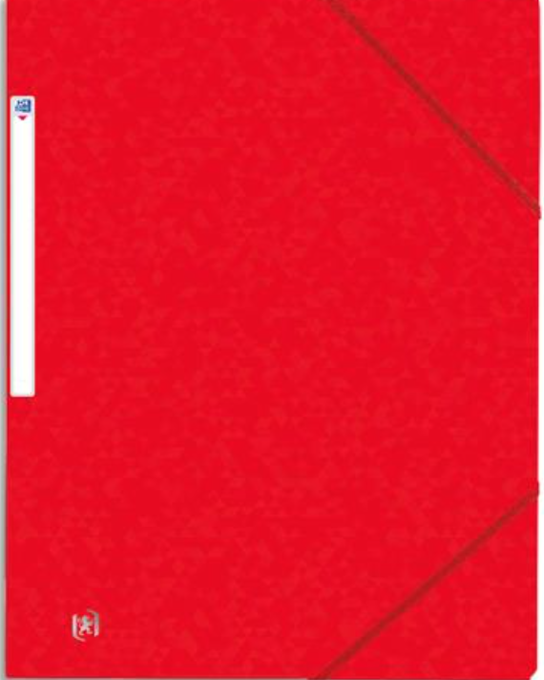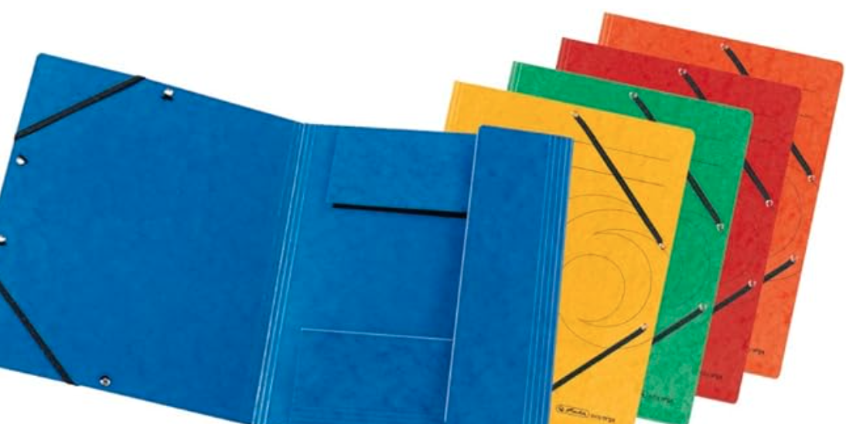  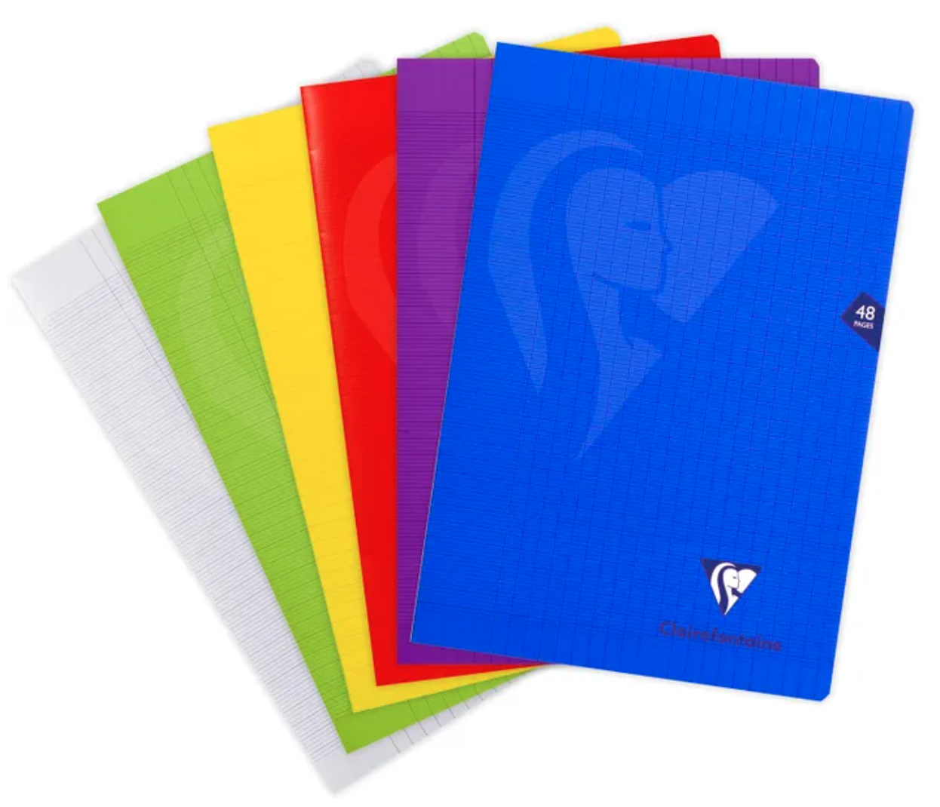

Arabic as a Foreign Language (AFL) students only
- Folder with Multiple Pocket (one only)
- Post-it tabs (one pack)

Modern Standard Arabic (MSA) students only)
- Folder with Multiple Pockets (one only)
- Headphones
- Pens & pencils
- Highlighters

The ASD Booster Club Store Will be selling:
- Combination Locks
- Stainless steel water bottles
- Swim caps

Special Days at ASD (for International Week and Week Without Walls)
You may want to consider bringing some special items from home for International Week/Week without Walls including the following:
- National Dress
- Favorite sports jersey
- National colors t-shirt
- Hiking/water shoes (Keen, Teva, Chacos, etc.)
- Lightweight raincoat/poncho
- Quick-dry clothing (shorts & T-shirts)
- Lightweight/compact sleeping bag

ASD Dress Code

Our dress code is meant to provide guidance for students and parents as to suitable attire for our school’s learning environment. While ASD does not have a school uniform (with the exception of clothes for P.E.), all students are expected to dress in a manner that both reflects our school values and contributes towards an academic atmosphere.

- Students’ clothes should cover their body from (and including) their shoulders down to three inches above the knee, as well as the waist. Wearing clothes that have holes or are see-through in this area is not acceptable. Also, underwear should not be visible.
- Jewelry, glasses, and t-shirt decorations and logos should be culturally sensitive and not offensive or inappropriate. Hats and sunglasses may only be worn outdoors.
- Distracting personal devices, such as cell phones and smartwatches, should not be worn or used during the school day. If they are brought to school, they should be turned off and put away in a student's locker.

If a student’s dress is not in line with these guidelines, they will be asked to change. If the student does not have alternate clothing, parents will be contacted. Please note that our dress code remains in effect during school-sponsored activities, including school socials and field trips.

Note: Dress Code During P.E.
Students are required to wear a P.E. shirt and appropriate athletic bottoms of their choice for their physical education classes. Middle school students that still have last year’s P.E. uniform (and it still fits) are welcome to wear it during this year’s classes.

