The school will provide a student planner at the beginning of the year
(students are expected to use the ASD MS Planner all year)

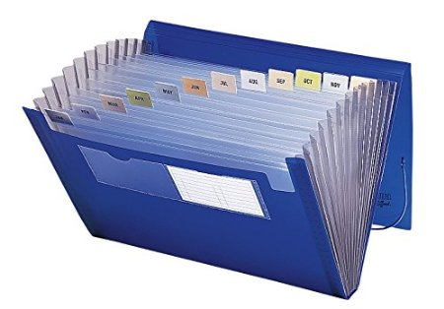
General Supplies (All Students)
- One Accordion Folder/Portfolio (10 tabs)  - Reusable Water Bottle with the name in permanent marker (also used in P.E.)  - 2 MasterLock Combination padlocks - for School locker and PE locker (Optional)  - NOTE: NO locks with keys  - Pencil Case - should hold:  - Four boxes of non-mechanical pencils (two will be collected by the grade-level LA teacher)  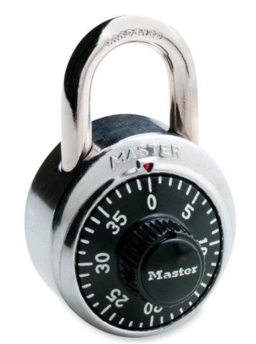  - Small pencil sharpener (NOT electric)  - Colored Pencils  - Highlighters (4 pack)  - Erasers (4+)  - Small pair of scissors  - Ruler  - Ink Pens - blue, black, red | *For Math:  - Two 4 packs (red, green, blue, black) Expo or Staedler brand whiteboard markers to be collected by the math teacher  - Two boxes of sharpened pencils with erasers  *The following materials will be collected by the LA teachers:  - 3x3 post-it pads (3)  - 2 boxes of pencils  *For Social Studies:  - A notebook with lined paper  *For Science:  - One two-pocket folder or accordion folder

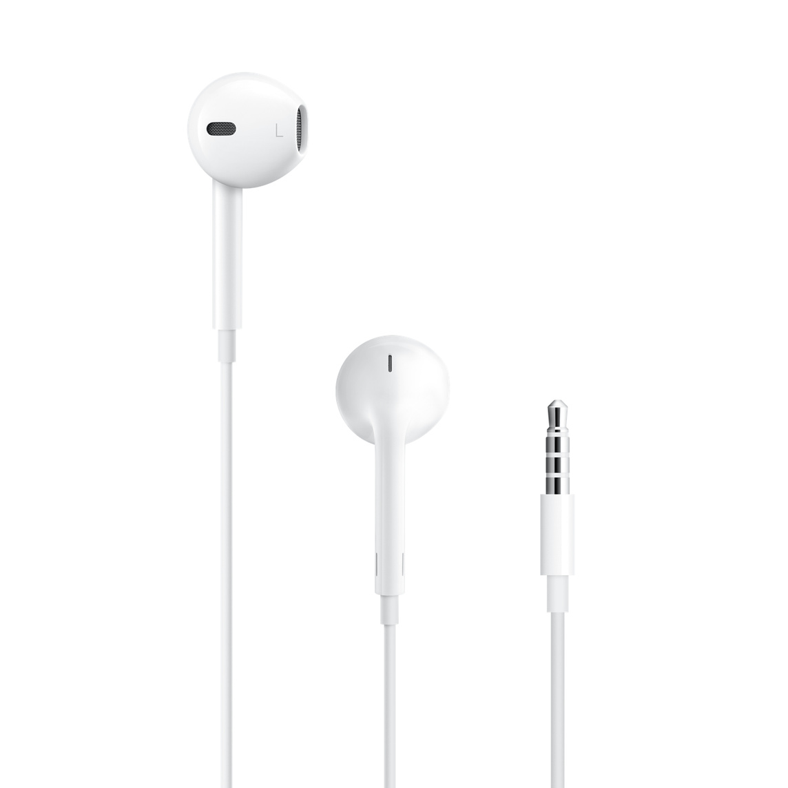 | Earphones with microphone  Please ensure that the earphones are specifically designed so that the microphone works with Apple products.
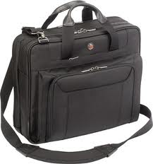 | Laptop Shoulder Bag  The computer bag MUST:  - Be padded  - Have a shoulder strap (note that this is not a laptop “sleeve”)  - Have an external pocket for the charger  - Be sized to fit at least a 13-inch MacBook Air laptop, but not be much larger than required.  PLEASE NOTE: This bag should NOT be a backpack that carries books or other items. The Computer Bag should be for the computer, charger, and earpod ONLY.

PE Supplies (All Students):
- Deodorant for PE class
- Water bottle
- Swimming Unit: Swim cap required and goggles strongly recommended
- Uniforms can be purchased from Noble House
They have a store and an online ordering system. More information can be found in Sahifa.

Music Supplies (All students):
- PLEASE NOTE: There is a 600 QR non-refundable fee for the rental of school-owned instruments. This is non-refundable. However, if students have their own instruments, or if students take choral music, there is no fee.
- All band students will be provided with a band method book & SmartMusic subscription at no cost.

Art Supplies (Art Students only):
All Required by the first day of class:  - Pencil case  - 1 fine tip permanent black marker  - 1 extra fine tip permanent black marker  - large eraser  - 2 pencils  - hand-held pencil sharpener  - 1 large glue stick  - Spiral Bound Sketchbook  ** Art supplies stores: Jarir Bookstore, Fire station Art shop, Color Note, Carrefour, WH Smith | 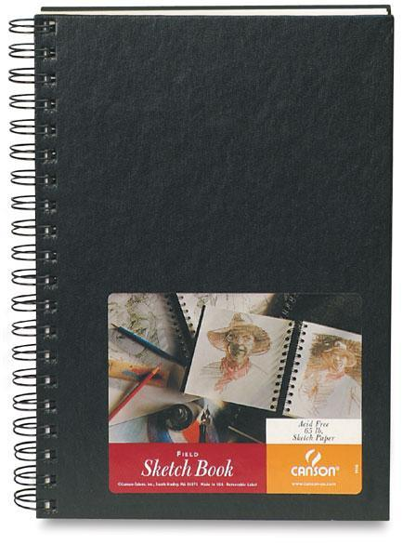  The spiral-bound sketchbook should look similar to this and have unlined white pages. It should measure around 9 x 12” (A4). When purchasing a sketchbook, please make sure that it is for drawing and NOT for watercolors or some other medium. It should say “sketch” somewhere on it.

World Language Students:
Spanish Supplies  (Spanish Students only) | - 1 large glue stick or tape  - Headphones  - Pen & pencil  - Highlighters: 3 different colors
French Supplies  (French Students only)  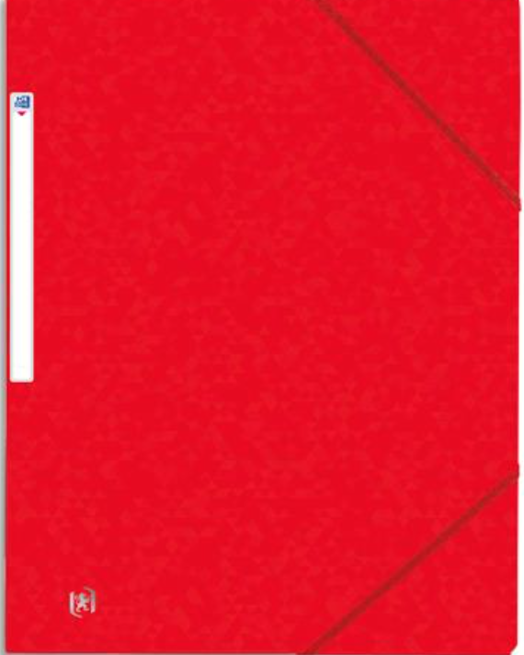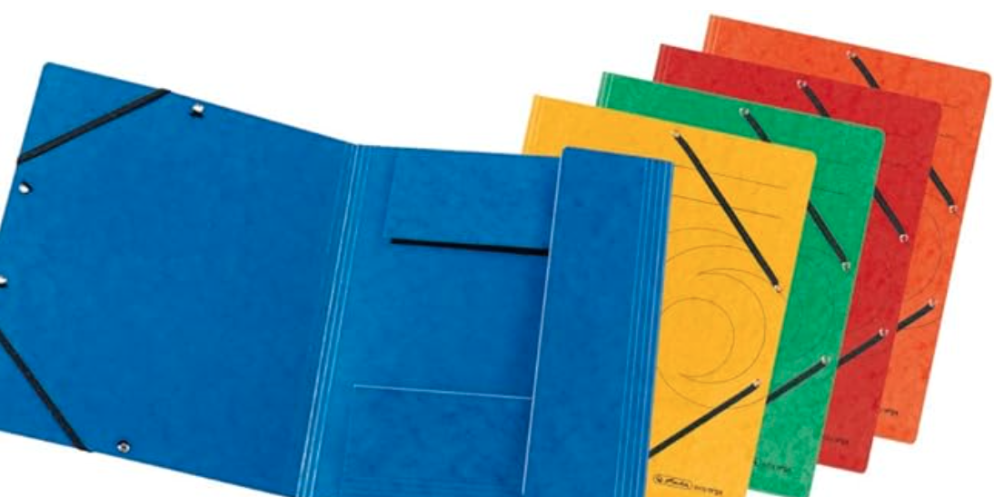  +  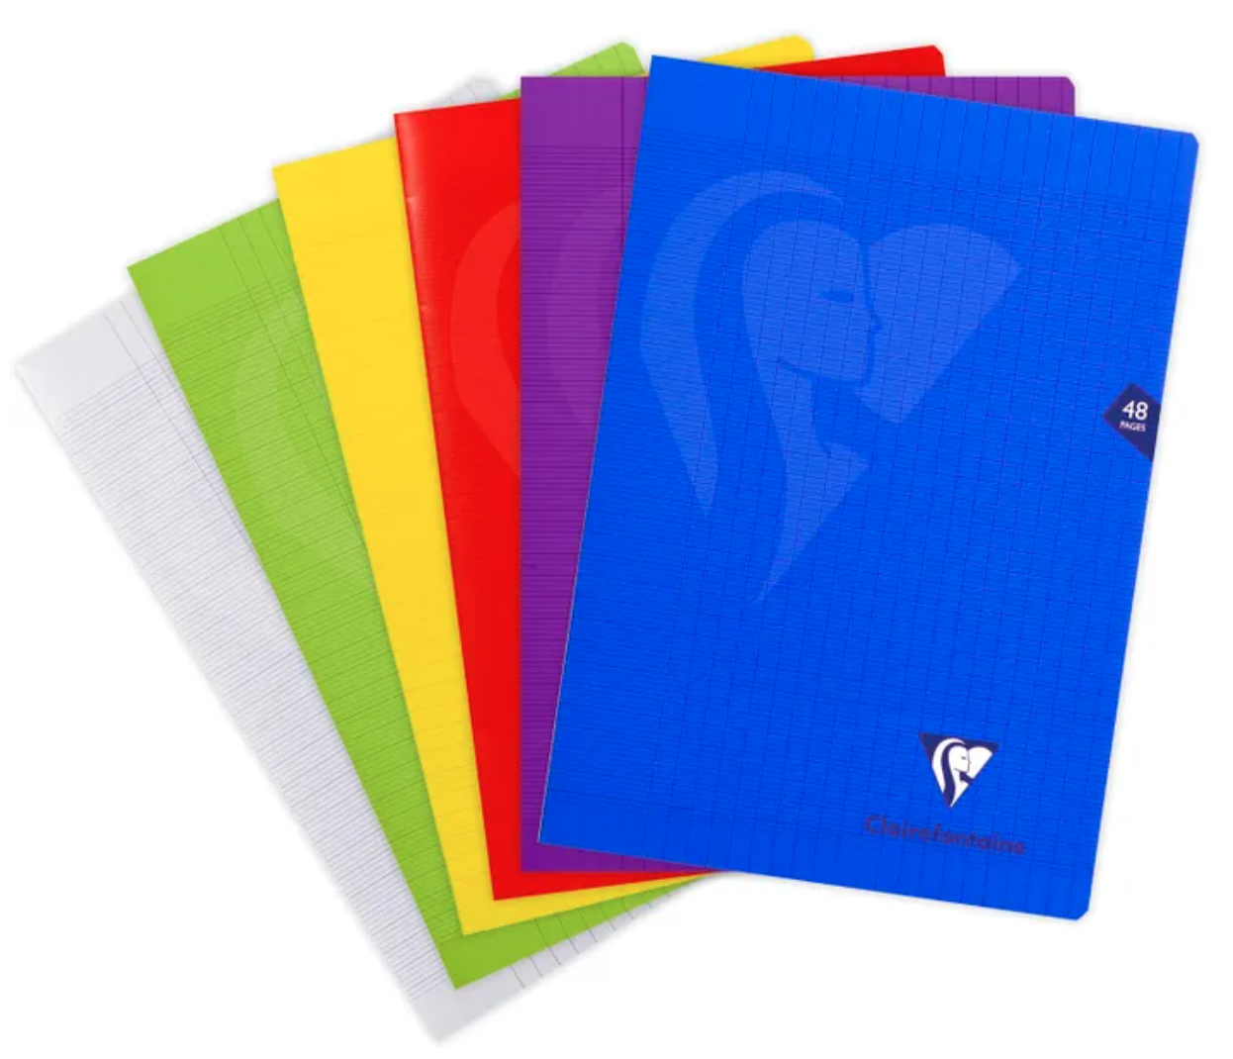 | - Pencils & Pens: blue/red/green  - Headphones  - One elastic folder  - One notebook ( Stapled notebook 21x29,7 cm 24 sh. Seyès - Mimesys, in polypropylene - Clairefontaine brand or Oxford brand
Arabic as a Foreign Language (AFL) (AFL students only) | - CLEAR BOOK A4 60 POCKET DELUXE /MAXI  - Highlighters  - A3 SInARLine/ Hard Blue cover & A4 SInARLine/ Hard Blue cover  - Headphones  *The following material will be collected by the AFL teacher:  - Glue Sticks (2)
Modern Standard Arabic  (MSA students only) | - Folder with Multiple Pockets (one only)  - Headphones  - Pens & pencils  - Highlighters

The ASD Booster Club Store Will be selling:
- Combination Locks
- Swim caps
- Stainless steel water bottles

Special Days at ASD (for International Week and Week Without Walls)
You may want to consider bringing some special items from home for International Week and Week without Walls including the following:
- National Dress
- Favorite sports jersey
- National colors t-shirt

ASD Dress Code

Our dress code is meant to provide guidance for students and parents as to suitable attire for our school’s learning environment. While ASD does not have a school uniform (with the exception of clothes for P.E.), all students are expected to dress in a manner that both reflects our school values and contributes to an academic atmosphere.

- Students’ clothes should cover their body from (and including) their shoulders down to three inches above the knee, as well as the waist. Wearing clothes that have holes or are see-through in this area is not acceptable. Also, underwear should not be visible.
- Jewelry, glasses, and t-shirt decorations and logos should be culturally sensitive and not offensive or inappropriate. Hats and sunglasses may only be worn outdoors.
- Distracting personal devices, such as cell phones and smartwatches, should not be worn or used during the school day. If they are brought to school, they should be turned off and put away in a student's locker.

If a student’s dress is not in line with these guidelines, they will be asked to change. If the student does not have alternate clothing, parents will be contacted. Please note that our dress code remains in effect during school-sponsored activities, including school socials and field trips.
Note: Dress Code During P.E.
Students are required to wear a P.E. uniform for their physical education classes. Middle school students who still have last year’s P.E. uniform (and it still fits) are welcome to wear it during this year’s classes.

